

**HEROES OF**

**THE BIBLE**

**SUPER**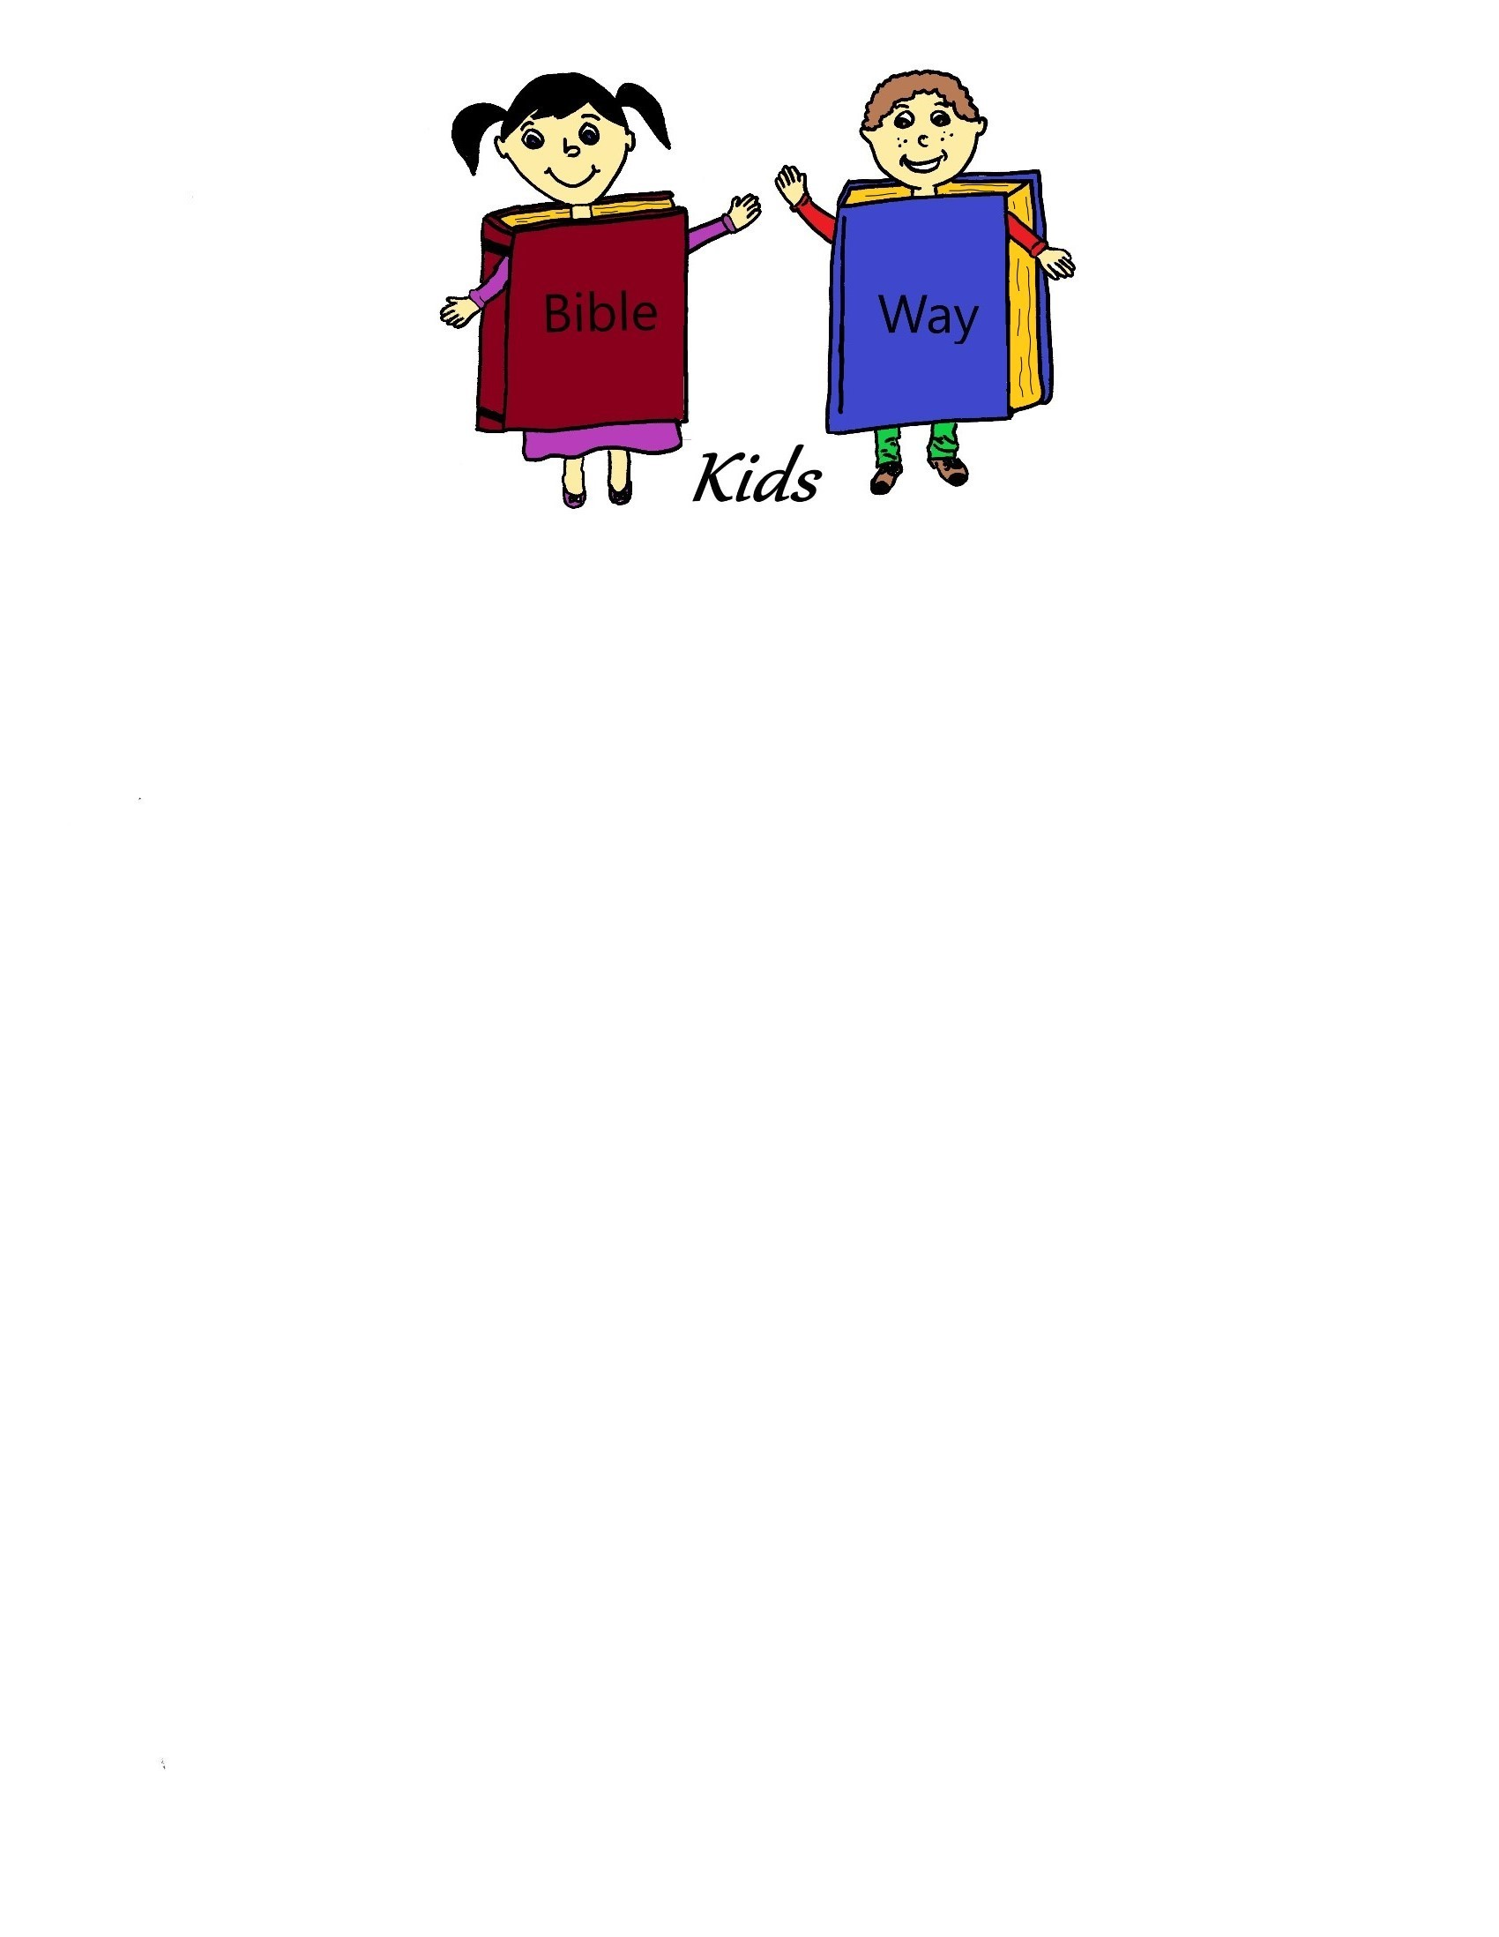

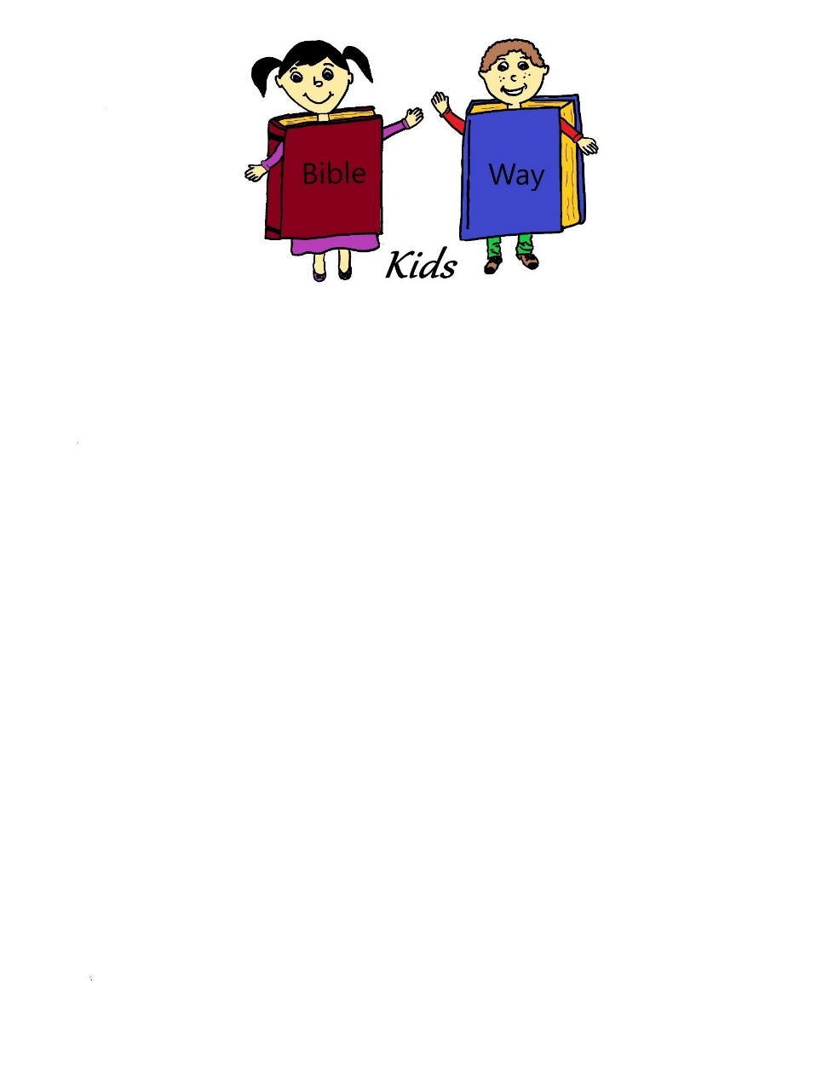A Bible Way Kids curriculum compiled by:   
Heritage Family Church  
3840 N. Seneca, Wichita, KS 67204  
316-942-6652

**Super Heroes of the Bible**

**Table of Contents**

**Lesson One:** Abel: Offered a More Excellent Sacrifice

**Lesson Two:** Enoch: He Pleased God

**Lesson Three:** Deborah and Barak: Fought a Mighty Army

**Lesson Four:** Abraham: He Looked for a City

**Lesson Five:** Sarah: She Believed God for a Baby

**Lesson Six:** Moses: Forsook Egypt

**Lesson Seven:** David: A Man After God’s Heart

**Lesson Eight**: Rahab: Sheltered the Spies

**Lesson Nine:** John the Baptist: Forerunner of Jesus

**Lesson Ten:** Jesus: Our Super Savior

Party and Review

**Super Heroes of the Bible**

The Super Heroes series is not about Batman or Superman or any of those other wimpy type heroes. Our heroes are true heroes. Men and women of God, Heroes of Faith. They are to be admired for their character and standing with God. We want to teach our children about the real heroes that they should be looking up to.

We took this series from Hebrew 11, Hall of Faith. We will be teaching each week about one of the Heroes of Faith.

The room décor is of course: Super Heroes. We had a special Hall of Faith area for each of the Super Heroes. We set up a photo booth area with the background of a city at night. We had a lighted night city on one wall and a large Super Hero on another wall. Black and dark blue table cloths.

The costumes were of course Super Hero capes with a large letter J on the back. J for Jesus, he’s the all time Super Hero. He’s always on time when we need Him to help us. He has all power and is all seeing-a true Super Hero.

The ladies had pink Super Hero capes, the guys could wear blue.

We introduced a theme song in our first lesson that we sang each session. “Jesus is our Super Hero”. We provide the words, you provide the tune. It can be set to any tune you choose or make up your own, ours was a combination of the two.

Where else can you go and be a Super Hero? Have fun!!



**Super Heroes of the Bible**

**Lesson One: Abel: Offered a More Perfect Sacrifice**

**Lesson at a Glance**

**Pre-session:** Ten oranges-5 perfect, 5 blemished

**Offering:** Super Hero cape with a J on the cape

**Songs:** Jesus is my Super Hero (Resources)

**Craft:** Card stock, crayons

**Memory Verse**: Dry Erase Board or Chalk Board

**Lesson:** Cape

**Super Heroes of the Bible**

**Lesson One: Abel: Offered a More Perfect Sacrifice**

**Scripture Text: Genesis 4:4**

**Memory Verse: I Samuel 15:22b …**Behold to obey is better than sacrifice, and to hearken than the fat of rams

**Welcome:** Welcome each child with a big smile and tell each one “you are super”.

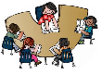**Pre-session:** Have ten oranges on the table, five should be perfect looking oranges, the others should have blemishes or bad spots on them. Have the children divide the fruit into two groups. The good fruit and the fruit that is blemished. Ask them why they put the blemished fruit into the bad group. Ask them which group they would give to God as an offering. (Hopefully they would choose the good fruit). Talk to them about why they would do that and talk about always giving God the best in their lives.

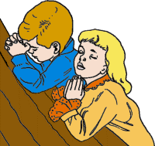**Prayer:** Pray with the children asking God to help us to be obedient to him and give him our best.

**Offering:** Place the offering on a Super Hero cape. Make sure the children notice the “J” on the back

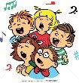**Songs:** Sing “Jesus, You’re my Super Hero” song.

**Craft:** Write the word OBEY in large letters on cardstock. Let the children outline the word over and over with different colors until the page is full.

**Memory Verse:** Write the memory verse on the dry erase board or chalk board. Read the memory verse aloud with the children erasing one word each time that the verse is read. By the time the last reading is done, the children will be reciting the verse by memory.

**Lesson:** Did you notice all the new stuff around here today? See my cape? Do you know why it has a big “J” on it. That’s for Jesus. He’s my Super Hero. We’re going to learn about other Super Heroes in this series. We’re starting today with a guy that maybe you might not think of as a Super Hero, but God did. He is listed in Hebrews in the Hall of Faith.

After Adam and Eve were sent out of the garden they were blessed with two beautiful boys. One was named Cain and the other was named Abel. They were very careful to raise their sons to worship and love God. They knew the mistakes they had made and they didn’t want their sons to repeat them.

They taught their sons the laws of God. One law that God had, was that the people were to bring a sacrifice to Him. The sacrifice was to be a blood sacrifice. That means they were to kill an animal and bring it to God to sacrifice as an offering before Him. Both of these young men knew what was required of them.

When they were young their parents made the sacrifices and they had watched how to do it. When they got old enough to make the sacrifices themselves they would know what to do.

The time came when they were old enough to do that. Abel brought a sacrifice that was pleasing to God. It was a sacrifice like he had been taught to bring and God was pleased with it. His brother Cain might have been a little lazier or just didn’t think doing things God’s way was important. He just went out into the field and gathered a sacrifice of the field. Maybe some vegetables or grains, whatever he could find. He knew better, didn’t he? God was not happy with Cain’s offering. God told Cain if he had brought the proper sacrifice he would have been accepted.

The amazing thing to me about Abel’s sacrifice was that God remembered it many years later. In the book of Hebrews chapter 11, the Bible lists the heroes of faith and Abel is among them. Just a young man doing what he knew God required is listed among such men as Abraham and Moses.

This lets us know that God places a high priority on obedience. Abel could have taken the easy way out, but it would not have pleased God. We want to please God with our lives don’t we? We should be obedient to our parents, teachers and pastor. Anything they ask us to do we should be willing to do. Most of all we should be obedient to God. He has a special plan for our lives and we need to obey Him in all things. Let’s pray and ask God to help us to be obedient. Pray with the children.

**Extended Time Game or Activity:** Play a game of Simon Says giving several children the opportunity to be Simon. This is an easy game that teaches the concept of obedience.



**Super Heroes of the Bible**

**Lesson Two: Enoch: He Pleased God**

**Lesson at a Glance**

**Pre-session:** Jumbo craft sticks: 2-1 per child, construction paper, glue, google eyes, crayons

**Offering:** Super Hero cape

**Craft:** Red and pink construction paper, white construction paper, crayons

**Memory Verse:** Dry Erase or Chalk board

**Extended Time Game or Activity:** Two capes, two Bibles

**Super Heroes of the Bible**

**Lesson Two: Enoch: He Pleased God**

**Scripture Text: Genesis 5:23-24**

**Memory Verse: Proverbs 16:7** When a man’s ways please the Lord, he maketh even his enemies to be at peace with him.

**Welcome:** Welcome each child with a warm smile.

**Pre-session:** Let the children make craft stick super heroes using the provided materials. They will color the popsicles with crayons. Glue triangles onto the back of the sticks and glue a small piece of construction paper near the top of the stick for the mask. They can place a letter “J” on the capes and glue on small google eyes.

**Prayer:** Pray with the children asking God to help them to be pleasing vessels to Him.

**Offering:** Let the children place their offering on the super hero cape.



**Songs:** Sing “Jesus You’re my Superhero”

**Craft:** Let the children cut out a red or pink heart and glue it onto the middle of a sheet of white paper. Let them draw an eye in front of the heart. The number 2 comes next and then the words “please God. They can add stickers or make a border around the picture if they choose.

**Memory Verse:** Using the dry erase or chalk board play a game of hangman using the memory verse. For younger children suggest letters that they can use and help them “read” the verse when it is done.

**Lesson:** The man we are going to talk about today is also mentioned in Hebrews in the Hall of Faith. I think the story of Enoch from [Genesis 5](http://biblegateway.com/bible?version=NLT&passage=Genesis+5) is one of the strangest stories in the Bible.

Enoch had a special relationship with God.The Bible says that Enoch walked with God. People back then didn’t do that sort of thing. Most of the people just did what they wanted to do and didn’t even think about God. God just wasn’t important to them. But He was to Enoch! He lived for God, not himself.

Genesis 5:23-24 tells us that Enoch lived 365 years, walking in close fellowship with God. Then one day he disappeared, because God took him. Where do you think he went? I think he went to heaven to live with God. Enoch had faith in God – he trusted that God would keep his promises. Because of that faith, Enoch chose to honor God. He was obedient and made God his first priority.

Enoch is famous, but do you know why? Most kids would guess that he’s famous because he never died. He just disappeared one day and went straight to heaven! But believe it or not, that’s not why he’s famous. [Hebrews 11](http://biblegateway.com/bible?version=NLT&passage=Hebrews+11) tells us that his faith is what really made him famous. [Hebrews 11:5](http://biblegateway.com/bible?version=NLT&passage=Hebrews+11%3A5) saysit was by faith that Enoch was taken up to heaven without dying—“he disappeared, because God took him.” For before he was taken up, he had a testimony, that he pleased God. Did you hear that? Before he disappeared straight to heaven, Enoch was already known for pleasing God. Everyone knew about him because he was a person who pleased God. When people looked at Enoch, they said, “I know him, that guy always obeys God.”

Just like Enoch, we can choose to make God our first priority. We can spend time with him by reading the Bible, praying, and serving others. The more we’re around God, the more we will know about him and want to live like him. There’s even more news: When we live a life of faith here on earth, we’ll get to be with Jesus in heaven someday. .. Our faith pleases God. If we have faith in God we will follow the plan of salvation, won’t we. Can anyone remember the plan of salvation? (Let the children answer). That’s right, repent, be baptized in Jesus Name and receive the gift of the Holy Ghost. Let’s all pray together that we can be pleasing to God like Enoch was and that we will follow the plan of salvation. Pray with the children.

**Extended Time Game or Activity:** Provide two capes and two Bibles for the game today.

Divide the children into two teams. The goal for each team is to run down to the end of the play area carrying the Bible. They are to pick up the super hero cape, put it on and run back to the next player-making sure they do not put down the Bible.

The next child in line runs down to the end with the cape and the Bible, puts the cape on, without putting down the Bible and runs back. Play continues until one team has completed.



**Super Heroes of the Bible**

**Lesson Three: Deborah and Barak: Defeated a Mighty Army**

**Lesson at a Glance**

**Pre-session:** Shields cut out of poster board or card board-one per child, aluminum foil, art materials

**Offering:** Super Hero cape

**Craft:** Paper plates, pretzel sticks (1 per child), apple slices (4 per child), black grapes (3 per child)

**Memory Verse:** Dry erase or chalk board, white paper, pencils

**Extended Time Game or Activity:** Two jump ropes

**Super Heroes of the Bible**

**Lesson Three: Deborah and Barak: Defeated a Mighty Army**

**Scripture Text: Judges 4**

**Memory Verse: I Corinthians 1:27b** ...and God hath chosen the weak things of the world to confound the things that are mighty.

**Welcome:** Welcome each child with a warm smile and a handshake.

**Pre-session:** Let the children make a shield and decorate it as they wish. Provide shields cut out of poster board or cardboard. The children can cover them in aluminum foil and then add decorative touches. Barak and Deborah used shields and super heroes sometimes do also.

**Prayer:** Pray with the children today asking God to help us to learn to be mighty in Him.

**Offering:** Let the children place their offering in the super hero cape.



**Craft:** Make a palm tree out of food today. The woman in our story judged her people as she sat under a palm tree. Give each child a paper plate, pretzel stick, 4 apple slices, three black grapes. The children will use the pretzel for the trunk of the tree, the apples for the fronds and place the grapes in the middle of the fronds. They can eat their creation when finished.

**Memory Verse:** Write the memory verse on the Dry erase or chalk board. Let the children copy the verse on a sheet of white paper and then pass the paper to the child on the right, they will write the verse again and pass the paper one more time to the right. Allow each child to read the verse out loud and then read as a group. The children can return the papers to the original owner for take home.

**Lesson:** We have a story today about how God used two people to do his will. Both of their names are listed in Hebrews in the Hall of Faith. They believed that God would help them have a mighty victory. It seemed like it was a lost cause, they were fighting a mighty army with bows and arrows. How could they win?

The first person in our story was named Deborah. She was a prophetess and a judge in Israel. The Bible says she dwelt under the palm tree of Deborah. Maybe she sat under the palm tree as she judged the people . All the people came to her when they had a problem and she helped them find the answer. She was very wise and listened to God. One day God told her to send for a man named Barak. He was a soldier that God wanted to use to defeat the armies that were bothering the Israelites.

Deborah told Barak that God wanted to defeat the Canaanites. Barak was afraid and said that he would only go to the battle if Deborah would go with him and his army. She agreed but told him, “God is going to give the victory by a woman”. Wow! How could a woman win a battle??

Deborah and Barak led the Israelite army into the battle against the Canaanites. God allowed them to lead the enemies into a marshy field. The Canaanites had large chariots with heavy iron wheels. When they took the chariots into the marshy, soggy fields the chariots became stuck. When this happened the Israelites used their bows and arrows and easily defeated the enemy.

That’s pretty amazing isn’t it. Deborah knew that God had spoken to her and she was willing to do what God asked her to do even though the odds were against her.

Barak was not as willing to go at first, but he trusted that Deborah had heard from God and he led his army into the battle with Deborah at his side.

They were listed in Hebrews because of their faith and their trust in God. They believed what God had told them and God gave them the victory.

You can trust in God too. He always keeps his promises. Let’s thank God together today that we can trust him. He is a wonderful friend and savior. Pray with the children.

**Extended Time Game or Activity:** Divide the children into two teams. Two children at a time from each team will compete. One child will have a rope looped around him and become the chariot, the other child will become the driver. The children will race each other down to the other end of the room and come back and tag the next two children. The first team with all their members back first wins the game.



**Super Heroes of the Bible**

**Lesson Four: Abraham: He Looked for a City**

**Lesson at a Glance**

**Pre-session:** Brown craft paper, pencils, crayons

**Offering:** Super Hero cape

**Craft:** Jumbo craft sticks-3 per child, colors, markers, construction paper, scissors, glue

**Memory Verse:** Chalk or duct tape, 5-6 pieces of construction with words or phrases of the memory verse written on them, small candy for prizes

**Extended Time Game or Activity:** Building blocks

**Super Heroes of the Bible**

**Lesson Four: Abraham: He Looked for a City**

**Scripture Text: Genesis 12**

**Memory Verse: Hebrews 11:10** For he looked for a city which hath foundations, whose builder and maker is God.

**Welcome:** Welcome each child with a smile.

**Pre-session:** Give each child a piece of brown craft paper and let them draw a map. Have several road maps on the table for them to look at. Remind them the top of the map is North and so on. They can draw a map of anywhere they choose-maybe from their home to church or they can draw a random road map. Abraham left his country not having a map, he was just obeying God.

**Prayer:** Pray with the children today that they will learn to trust in God.

**Offering:** Let the children place their offerings on the super hero cape.

**Songs:** Sing, “Jesus You’re my Super Hero”

**Craft:** The children will be making craft stick tents today. Abraham was on a journey and he stayed in tents as he traveled. Give each child three jumbo craft sticks and let them color them with markers or crayons. Glue the craft sticks into a triangle angle and glue them together. Cut a triangle out of construction paper or card stock to fit the opening of the triangle. Cut out a door for the tent and add a campfire out of construction paper on the side.

**Memory Verse:** Make a road on the floor with chalk or duct tape. Write the memory verse in phrases on pieces of construction paper and tape them in intervals along the road. Let the children one at a time start at the beginning of the road and say their memory verse as they go down the road. Have several teachers along the road to help if needed. Have a stop sign at the end and reward each child for following the road with a small piece of candy. When all are done, read the memory verse together as a group. Abraham didn’t have a paved road to follow he just followed God.

**Lesson:** We have been doing activities today about a man named Abraham. He is listed in the book of Hebrews Hall of Faith that we have been learning about.

God spoke to Abraham in Genesis 12 and told him to “Go from your country, your people, and your father’s household to the land I will show you.” When we do something for the very first time it can be a little bit scary. Do you remember your very first day at school? Your mother probably went in with you to help you find your room and meet your teacher. When you got on a bicycle for the first time, someone probably walked along beside you and helped hold you up at the very beginning. That gave you confidence and soon you were riding on your own. When you went swimming for the first time, you didn't just go out and jump in the pool, did you? No, there was someone with you to hold you up until you could swim on your own. It really helps if we have someone we trust to be with us when we are about to do something we have never done before.

God told Abram to leave everything behind and to move to a new country. He didn't even tell him where this country was. He just said, "Go to the land that I will show you." They didn't know where they were going or what they would find when they got there. It was like they were wearing a blindfold, but they trusted God --- and like we trust our parents to help us do new things. So, even though they were a bit scared, they left everything and set out on the journey to the place that God showed them. It took many years, but God was with them and he led them to their new home.

How about you, do you ever do new things that you’re not sure about. I know I do when it comes to witnessing sometimes (choose an example that fits). I want to witness to people about Jesus, but it doesn’t always feel comfortable. That’s why I’m glad I have Jesus to go with me, when I talk to people. He’s right there beside me letting me know everything will be alright.

Abraham had great faith in God and we want to have faith in God too. That means we know He’ll take care of every situation in our lives. He knows what’s best for us. Let’s pray and ask God to help us to learn to have faith in Him and trust him with our lives. Pray with the children.

**Extended Time Game or Activity:** Our memory verse today says that Abraham looked for a city whose builder and maker was God. Use the building blocks to make a city. Remember to include roads and tall and short buildings. Let all the children work together to build the city.



**Super Heroes of the Bible**

**Lesson Five: Sarah: She Believed God for a Baby**

**Lesson at a Glance**

**Offering:** Blue baby blanket

**Craft:** White paper, markers, crayons, paper plates, stapler, blue ribbon

**Memory Verse:** Homemade of store bought masks (can be found at party stores)-one per child, sharpie

**Lesson:** Suitcase with a few diapers in it, baby doll wrapped in blue

**Game:** Disposable diapers-one per child, blue balloons-one per child

**Super Heroes of the Bible**

**Lesson Five: Sarah: She Believed God for a Baby**

**Scripture Text: Genesis 21**

**Memory Verse: Luke 1:37** For with God nothing shall be impossible

**Welcome:** Give each child a warm welcome and a candy pacifier.

**Pre-session:** Purchase inexpensive baby shower napkins. Give each a blue frosted cupcake and a cup of blue sprinkles. Let them put their sprinkles on and then eat the cupcake. Talk to them about a baby being born in the story today.

**Prayer:** Thank the Lord today that he always keeps his promises.

**Offering:** Let the children place their offering on a blue baby blanket today.



**Songs:** Sing, “Jesus You’re my Super Hero”

**Craft:** Give the children a white piece of paper and a paper plate. Let them draw a face of a baby the same size as the middle of the plate. Cut out the baby face and glue onto the middle of the plate. Fold each side of the plate over so that only the face is showing, (this will be blanket). Staple or tape down and glue a blue ribbon on the top. They may color the blanket blue if they desire.

**Memory Verse:** Write the memory verse on the dry erase or chalk board. Make two sets of masks or buy inexpensive store bought ones. With a sharpie write one word of the memory verse on each mask.(Make two sets). Divide the children into two teams. Give one set of masks to each team. At “go” the children put on the masks and place themselves in correct memory verse order. They must line up in the correct order and then read the verse out loud as a group. The first team to complete wins.

## Lesson: (Bring a suitcase with a few baby diapers packed in it, have a baby doll wrapped in blue). Remember last week we talked about Abraham, he was listed in the Hall of Faith in the book of Hebrews. Well, today we’re going to talk about his wife. She was also listed in the Hall of Faith.

Some really interesting and amazing things happened to Abraham’s wife. Her name was Sarai, but God changed her name to Sarah. He also changed her address. When God told her husband to go to a country that He would lead him to, she packed her bag and went with him (show the suitcase). She never doubted God had spoken to her husband and she trusted God right along with Abraham.

Sarah and Abraham had one thing that they really wanted. They wanted to have a baby. But, there was a big problem, Sarah was too old to have children now. They never had children when they were younger and probably thought they would never get to enjoy the pleasures of a child in their home. But God had other plans. He promised Abraham that he would have a child in his old age. He was a promised seed and Abraham’s descendants would be as numerous as the stars in the sky and the sand on the seashore. How could that be when Abraham was almost 100 years old and Sarah was almost 90? We would say that was impossible wouldn’t we? Let’s say our memory verse together. (say the verse) That’s right with God nothing is impossible.

So Sarah had another change in her life. (open the suitcase and take out a diaper, pick up the doll). She was going to be changing diapers. Sarah was 90 years old when her baby Isaac was born and Abraham was 100. Oh, how they loved that baby. He was their promise from God.

Sarah probably had times when she wasn’t sure God’s promise was true, in fact one time she even laughed at the idea, but God heard her and knew her heart. She really wanted to trust God. He had never failed her. Because of her faith in Him she was rewarded with a beautiful baby boy. Let’s pray and ask God to help us to learn to trust him and have faith in Him. We know every promise in the Bible is true and will come to pass. Pray with the children.

**Extended Time Game and Activity: Diaper the Baby**

At one end of the room set up two small tables with one diaper for each child.

Divide the children into two teams and give each child a blue balloon. The children will blow up their balloon, race down to the opposite end, put a diaper on their balloon and race back to their team. Play will continue until all children have completed the task. The team with everyone back first is the winner. (This is a hilarious game and the children have a lot of fun with it, make sure everyone gets a chance to diaper their balloon).



**Super Heroes of the Bible**

**Lesson Six: Moses: Forsook Egypt**

**Lesson at a Glance**

**Welcome:** Slips of paper for drawing, pencils

**Pre-session:** Brown butcher paper-cut out one cape for each child, ribbon or yarn, art materials

**Offering:** Super Hero cape

**Craft:** Glittery art material, card stock

**Memory Verse:** Dry erase or chalk board, two poster boards, scissors, markers-Write the memory verse of each of the poster boards and then cut them into puzzle pieces

**Lesson:** Two gifts wrapped-one in beautiful paper with two pennies in it, one wrapped in a brown paper bag with a $5.00 bill in it, $5.00 McDonalds gift card, drawing slips from Welcome

**Extended Time Game or Activity**: Brown bag with assorted small candies, review questions

**Super Heroes of the Bible**

**Lesson Six: Moses: Forsook Egypt**

**Scripture Text: Exodus 2**

**Memory Verse: Hebrews 11:27** By faith he forsook Egypt, not fearing the wrath of the king: for he endured, as seeing him who is invisible.

**Welcome:** Welcome the children with a warm smile. Let each child write their name on a slip of paper for the drawing during the lesson.

**Pre-session:** Give each child a cape cut out of brown butcher paper. (This is a simple modified triangle- you can scallop the edges if you desire). Give them art materials and let them design it as they choose. Try to lean away from worldly super heroes and let the design and talk be about the Heroes we have studied thus far.

**Prayer:** Let the children worship the Lord. Lead them in a time of praise.

**Offering:** Let the children put their offering on the Super Hero cape.



**Songs:** Sing, “Jesus You’re my Super Hero

**Craft:** Talk to the children about what a palace or king’s house looks like. Have lots of glittery art material available for the children to work with today. Give the children two pieces of card stock. On one ask them to use the art materials to draw a palace and decorate it. Remind them that palaces are where kings live and they are very fancy. On the other sheet have the children draw a simple tent and camp scene. When they are done, explain to them that the man in our story today had a choice about which place he would live in.

**Memory Verse:** Write the memory verse on a dry erase or chalk board. Write the memory verse on two large poster boards and then cut into puzzle pieces. Divide the group into two teams. Let the children put the puzzle back together in memory verse order and then stand and read the verse together. The first group to complete is the winner. Read the verse together as a group several times.

**Lesson:** (Have two gifts wrapped-one wrapped in beautiful wrapping paper with a big bow, the other wrapped in a brown paper bag with no other decorations on it. Put two pennies in the beautiful box and a five dollar bill in the simple bag.)

Before we start our story today, I want to give away a couple of presents, isn’t that nice of me! You put your names in the drawing when you came in and we’re going to pick two winners. (Draw the first name). Okay, ________, you can choose the first gift. (Let the child choose). Now, (draw the second name),______ you get the other gift. No peeking at the gifts until the end of the story. I’ll keep them right here for you.

Our story today is about another man that was listed in the Hebrews Hall of Faith. His name was Moses. I’m sure you’ve heard a lot of stories about him in Sunday School. He did a lot of amazing things with God working with him. He was a man of faith.

Before Moses became a man of faith, he was a young man that had a hard decision to make. You see, Moses was born into a Hebrew family that were slaves to Pharaoh in Egypt. By the miraculous hand of God, Moses was raised by Pharaoh’s daughter in the Palace. His mother was hired as his nurse maid and took care of him in the palace when he was young. No doubt, even though he was living among people that worshiped idols and did not know the one true God, Moses was taught about Him. His mother probably told him every day “Hear O’ Israel the Lord our God is one Lord and Him only shalt thou serve”. She never wanted Moses to forget that he was a Hebrew, one of God’s chosen people.

So, Moses grew up with a kind of mixed up life. He had lots of food and beautiful clothes and anything that he wanted, but his brothers and sisters were growing up as slaves. Moses never forgot the teachings of his mother as he grew older. He never forgot that he was really a Hebrew and there was one true God.

One day as he was out walking he saw an Egyptian soldier beating one of the Hebrews. Moses was so angry he killed the Egyptian and buried his body. He didn’t think anyone had seen what had happened and he went on his way thinking that was the case. Later two of the Hebrews were fighting and when he went to break up the fight, they reminded him of his killing of the Egyptian.

Moses knew the Pharaoh would find out and possibly kill him. He could have gone to Pharaoh’s daughter and pleaded his case, she dearly loved him and he could probably have gotten out of it. But Moses made a decision that day that impacted the rest of his life. Moses left Egypt and went into the desert to live. It was there that God began to deal with Moses and let him know His plan for his life.

Our memory verse says that Moses forsook Egypt, not fearing the king. He became a faith filled man trusting in God and later led the Hebrews out of the slavery of Egypt.

Moses made the choice to do right and live in the desert with his people rather than to enjoy the pleasures of Pharaohs house. He could have stayed there and worshiped the idols of Egypt, but he chose to worship the one true God.

Let’s lift up our hands and worship the one true God. Worship with the children.

(After the worship continue with the gifts). Oh, I almost forgot to give the two winners their gifts. Relate the story to the gift choices, depending on the choice of the first child that chose the gift. (If the first child made the right choice and picked the paper bag, let the other child open their beautiful gift and then give them a $5.00 gift card to McDonalds.

**Extended Time Game or Activity:** Hot Potato Surprise Game

Seat the children in the circle. Begin passing the bag of candies. When the music stops the child holding the bag is asked a review question. If they answer correctly they may choose a candy, if not play continues. Continue play until all the children have had a chance to answer. Give everyone a piece of candy when play is over.



**Super Heroes of the Bible**

**Lesson Seven: David: A Man After God’s Own Heart**

**Lesson at a Glance**

**Welcome:** Heart stickers

**Pre-session:** Pink and red construction paper, white paper doilies

**Offering:** Heart shaped container

**Craft:** Blank CD’s-one per child, paint sticks-one per child, small glue on jewels (Before class hot glue the paint sticks onto the CD’s)

**Memory Verse:** Pink and red hearts with memory verse written in words or phrases on them.

**Extended Time Game or Activity:** Red and pink hearts-See Lesson

**Super Heroes of the Bible**

**Lesson Seven: David: A Man After God’s Own Heart**

**Scripture Text: Acts 13:22**

**Memory Verse: Psalm 51:10** Create in me a clean heart, O God; and renew a right spirit within me.

**Welcome:** Welcome each child with a smile and give each one a heart sticker to wear.

**Pre-session:** Let the children make a valentine for Jesus. They can cut out hearts and use paper doilies to decorate the valentine. The focus is on letting Jesus know our hearts belong to him.

**Prayer:** Pray the memory verse today with the children.

**Offering:** Let the children put their offering in a heart shaped container.



**Songs:** Sing, “Jesus You’re my Super Hero”

**Craft:** Super Hero Scepters. Give children the CD and the paint stick. Let them decorate the CD with small jewels around the edges. Explain to the children that kings used scepters to allow others to come into their presence. The man in our story was a king.

**Memory Verse:** Write the memory verse on pink and red hearts with a word or phrase on each heart. Place the hearts in mixed up order on the wall. Let the children work together to unscramble the hearts and place them in order. When they have it completed, read the memory verse and then turn one heart over. Continue reading the verse until all the hearts are turned over. The children will now be able to recite the verse without looking at it.

**Lesson:** Time to hear about about another man in the Hebrews Hall of Faith. This man is a well know Bible character. I’ll give you a few clues: he took care of sheep, he played a harp, he killed a giant. That last clue gave it away didn’t it? Yes we are going to talk about David.

It’s interesting that in David’s lifetime, he went from being a little shepherd boy to becoming the King. David learned some important lessons while watching his sheep. It was probably pretty quiet on those hills watching the sheep and David had a lot of time to pray and to sing unto the Lord. David wrote the Psalms in the Bible, maybe a lot of those came from his times of being alone with the sheep.

David was not always a good man. He committed some very bad sins, he even had a man killed so that he could marry the man’s wife! That’s very bad isn’t it.

Yet, in Acts 13:22 God said he found David to be a man after His own heart, which shall fulfil all my will.

When David was confronted by the Prophet Nathan about his sin, he was remorseful and repentant. He still had to face the consequences of his sin, but he wanted God to forgive him. David was a man willing to do whatever God asked him to do, he was willing to fulfill God’s will for his life.

David loved God and wanted God to direct his life. That’s what we want for our lives isn’t it? Wouldn’t it be wonderful if God could say we were boys and girls after God’s own heart?

David had faith that God plans were better than his. That’s what faith is, believing even when it doesn’t look all rosy and good. Let’s pray and ask God to help us to have faith in him and be children after the heart of God. Pray with the children.

**Extended Time Game or Activity:** Hide several red and pink hearts around the playing area. They should have numbers 1, 2 or 3 written on the back of them. Write one task that the children should do on the back with the number. (1 Do three jumping jacks, etc…) Let the children search the area for the hearts and then find the other hearts that match them. After finding their other hearts, they must complete the task on the back and then return to the teacher. The first group back to the teacher wins.



Super Heroes of the Bible

Lesson Eight Rahab: She Sheltered the Spies

Lesson at a Glance

**Welcome:** Play magnifying glasses-one per child

**Pre-session:** White paper, cotton swabs, lemon juice in bowl with a little water (squeeze juice of a lemon into bowl add a little water), small lamp

**Offering:** Super Hero cape

**Craft:** Red yarn or ribbon, key rings

**Memory Verse:** 6-8 Slips of paper with words or phrases of memory verse, (2 sets), balloons-one per child

**Super Heroes of the Bible**

**Lesson Eight: Rahab: She Sheltered the Spies**

**Scripture Text: Joshua 2**

**Memory Verse: I Corinthians 2:5** That your faith should not stand in the wisdom of men, but in the power of God.

**Welcome:** Greet each child with a warm smile and a play magnifying glass.

**Pre-session:** Give each child a white sheet of paper and a cotton swab. The children will dip the cotton swab into lemon juice mixed with a little water and write a secret message. Let the message dry. The teacher can hold the message over a lamp with an exposed light bulb. The message will appear and the children can give it to their friends to read.

**Prayer:** Let’s worship the Lord today and give him Praise for the great things he has done.

**Offering:** Let the children put their offering on the Super Hero cape

**Songs:** Sing, “Jesus You’re My Super Hero”

**Craft:** Give each child three strands of thick red yarn or ribbon. Show them how to braid the ribbons to make a thicker strand. Connect the ribbon to a key ring at the top and tie the ends at the bottom. The children may use these as a key ring or a book mark and think of Rahab when they use them.

**Memory Verse:** Write the memory verse on slips of paper, a few words or phrases on each slip and place them into red balloons. Blow up the balloons. Make two sets. Divide the children into two groups and give each child a balloon. At go, the children will stomp on their balloons, gather up the memory verse slips and put the memory verse together. They then must read the verse aloud as a group. The first team to complete the task wins the game. Read the verse together as a whole group.

**Lesson:** Our story today is about another of the Hebrews Hall of Faith people . Today it is about a lady who had a lot of faith. She had faith in a God that she did not know and faith in Joshua and two spies.

Joshua must have wondered how they would ever capture the city of Jericho. Maybe he could even see its thick stone walls from their camp. How would he ever get enough men inside to take it over? They had no battering rams or any other weapons strong enough to break through its walls. Joshua knew one thing for sure, though - - if God fought for them, no walls in the world were strong enough to stop them.  
  
Joshua had sent two spies into Jericho to get information before they crossed the Jordan. When the king tried to capture the spies, a woman named Rahab hid them under flax stalks on her roof. She had heard stories of the victories that God had given the Israelites. She really didn’t know anything about their God but she knew he was powerful and she wanted to know more about him. She took a risk in hiding the spies, she would have been killed for treason if they found the spies in her house.  
The king had locked the gates to trap the spies inside Jericho, and Rahab offered to help them escape on one condition - - when the city fell, as she knew it would, she and her family would be saved alive. The spies agreed to do this, then she let them down by a rope through a window. Since her house was on the outside of the wall, they could get away and run back to the camp at Gilgal. Before they left, however, they told Rahab to hang a scarlet cord from that same window so the army of the Israelites would not hurt them.

The king of Jericho shut up all the gates so no one could go out or come in. Then God told Joshua exactly how to capture Jericho, commanding, “You shall march around the city . . . you shall go all around the city once. This you shall do for six days.” On the seventh day they marched around the same way seven times, but on the seventh time, everyone would shout and the walls would fall down.  
  
What do you think the people of Jericho thought? They could look out from the wall and see this strange parade - - day after day, silent except for the blowing of the priests’ trumpets. What was going to happen?  
  
On the seventh day they found out. The Israelites started about daylight that day, going around six times instead of one time as they had done before. On their seventh round, Joshua commanded them, “Shout, for the Lord has given you the city!”  
  
The Bible says when “the people shouted with a great shout that the wall fell down flat. Then the people went up into the city, every man straight before him, and they took the city.” But they saved Rahab and her family alive when they saw the scarlet cord hanging out of her window.

How happy Rahab was that she had made the right choice. She was eager to learn more about the God of the Israelites.

Rahab’s mention in the book of Hebrews lets us know that God honored her faith.

We want to be like Rahab and be willing to trust God with our lives. Let’s pray today and ask God to help us love Him and trust him.

**Extended Time Game or Activity:** Play a game of I Spy.



**Super Heroes of the Bible**

**Lesson Nine: John the Baptist: Forerunner of Jesus**

**Lesson at a Glance**

**Pre-session:** Bread, peanut butter, honey, disposable knives, plates

**Offering:** Super Hero cape

**Craft:** baggies, spring clothespins, pipe cleaners, google eyes, green wire

**Memory Verse:** Dry erase or chalk board, Karaoke or tape player and tape

**Extended Time Game or Activity:** Review questions about the Super Hero stories.

**Super Heroes of the Bible**

**Lesson Nine: John the Baptist: Forerunner of Jesus**

**Scripture Text: Matthew 14**

**Memory Verse: Romans 10:17** So then faith cometh by hearing, and hearing by the word of God.

**Welcome:** Welcome each child with a warm smile and a hand shake.

**Pre-session:** Give the children a peanut butter and honey sandwich. Tell them that the man in our story today lived in the desert and ate wild honey. (Check for any peanut butter allergies).

**Prayer:** Thank God for the truth of the Word of God today.

**Offering:** Let the children put their offering on the Super Hero Cape

**Songs:** Sing, “Jesus, You’re my Super Hero”

**Craft:** Give each child a baggie with the art supplies needed to make a locust. A locust looked like a grasshopper. The Bible says the man in our story ate locust and wild honey. We already had the honey, ask the children if they’d like to eat a locust. Most will answer no. Okay, let’s just make one. The children will color their clothespin green. They will loop the pipe cleaner to make the legs and add google eyes and antennae.

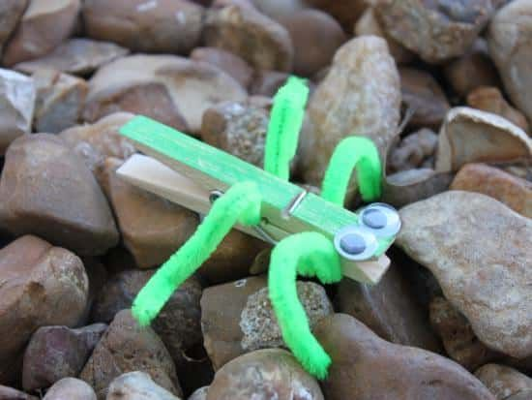

Memory Verse: Write the memory verse on a dry erase or chalk board. Bring a karaoke or a tape player and record each child reading the memory verse. Let the other children listen quietly. Play back the recordings. The children will enjoy hearing themselves and think of how many times they will have heard the verse. (This is a good activity for auditory learners)

**Lesson:** Our last person that we are learning about in the Hebrews Hall of Faith is not listed by name. He is listed by the some of the things he endured. Talking of some of the people in the chapter a reference is made that they wandered in deserts, and were killed for the gospel that they preached. The man in our story today fits in both of those categories.

John the Baptist was actually a cousin of Jesus. When he grew up he lived in the desert and preached about Jesus. He was called the forerunner of Christ, or the one that was coming before to tell people about the Messiah.

When he lived in the desert he ate wild locust (grasshoppers and honey). Doesn’t sound like a great diet to me. John the Baptist baptized Jesus and went on to preach about Jesus and taught the people to repent and turn from their sinful ways.

That got him in trouble and cost him his life. He was put in prison for telling a king that he should not have married his brother’s wife. He wasn’t afraid to call sin, sin.

The king’s new wife was not happy about John the Baptist calling her a sinner. She didn’t care if she had done wrong and she didn’t want him telling her she was wrong.

One day the king had a party and the dancer for the party was the new wife’s teen age daughter. She entertained at the party so well that the king told her he would give her anything she wanted. Her mother had told her to ask for John the Baptist’s head on a plate. Can you believe that? She was some mad woman. The daughter went to the king with her request, he was not real happy about it, but he had made the promise and had to keep it. John the Baptist was beheaded for preaching the gospel. In all of this he was faithful. He did not back off from preaching truth even when it cost him his life.

Do we love the Bible and God’s truth enough to die for it? We should plant the word of God in our hearts by reading our Bible and listening to the preached word of God. We want to hide his word in our hearts that we might not sin against him. John was mighty in faith, let’s pray and ask God to help us be mighty in faith and to stand for truth no matter what, pray with the children.

**Extended Time Game or Activity:** Play a review game. Write clues on index cards about the people they have learned about in Super Heroes. You can play boys versus girls or divide into teams. If a child cannot answer a question the other team gets a chance to answer plus another turn.



**Super Heroes of the Bible**

**Lesson Ten: Jesus: Our Super Savior**

**Lesson at a Glance**

**Pre-session:** Dry erase or chalk board, ruled paper, pencils

**Offering:** Super Hero cape

**Craft:** Construction paper strips to make paper chains, glue, crayons or markers

**Memory Verse:** Dry erase or chalkboard, card stock, pencils, wrapped hard candy, feely stickers

**Lesson:** Pre-session papers, sin chains from Craft

**Extended Time Game or activity:** Dry erase or chalk board

**Super Heroes of the Bible**

**Lesson Ten: Jesus: Our Super Savior**

**Scripture Text: The Bible**

**Memory Verse: Acts: 4:12** Neither is there salvation in any other: for there is none other name under heaven given among men, whereby we must be saved.

**Welcome:** Give each child a warm welcome, making sure you call them by name.

**Pre-session:** On the dry erase or chalk board write “Jesus is my Super Hero because:” Give each child a ruled piece of paper and have them copy the title on their page. Tell them to write underneath all the reasons why Jesus is their Super Hero. They can write anything they want , spelling is not an issue today, we just want to start them thinking about all the things Jesus is to them. (For younger children have them draw a picture of what Jesus is to them). They will be using their papers during the story.

**Prayer:** Thank the Lord today that He is the one true God and we know His Name.

**Offering:** Let the children put their offering on the Super Hero cape

**Songs:** Sing, “Jesus, You’re My Super Hero”

**Craft:** Using the construction paper strips that have been made let the children write sins that we can have in our lives, one sin on each strip. Let them make as many sin strips as they want and when done put them together in a chain. They can add their sin chain to the rest of the children’s when done to make one large sin chain. We will be using this in the story today.

**Memory Verse:** Write the memory verse on the dry erase or chalk board.

We want to reinforce the name of Jesus with this memory verse today.

Give each child a copy of the memory verse written on a piece of card stock. We are going to try to use as many or our senses as we can to learn the verse. Children learn in various ways and we want to try to tap into what works for each child.

1. Underneath the copy of the memory verse tell the children to rewrite the verse.

2. Let each child read the memory verse to you and reward them with a few pieces of wrapped hard candy. They can glue them onto their memory verse or eat them.

3. Let the children put feely stickers on the memory verse to decorate it .Make sure they are stickers that they can feel.

4. Sing the memory verse with the children. The tune is not important nor that you can sing or not. This is a very productive way to teach the verse.

5. As a group read the memory verse aloud several times.

**Lesson: (Have the children bring their papers from Pre-session and the chains that they made in Craft)** Wow! Time sure flies when you’re having fun. We are at our last lesson in Super Heroes of the Bible. Next week will be a party and review. That will be a lot of fun.

We have learned about a lot of different people in the Hebrews Hall of Faith, haven’t we? Today our lesson is not about a person that was in the Hebrews Hall of Faith because He is still living today. Can anyone guess who that is? That’s right, it’s Jesus. We know that Jesus was God manifested in the flesh when He lived on the earth. They did crucify Him and He did shed his blood for us. But he used His power and was raised from the dead on the third day. He lives in our lives as the Holy Ghost now and gives us power to overcome the devil.

So, Jesus is our Super Savior. We have super powers too, when we receive the Holy Ghost. The devil thinks he’s such a tough guy. He doesn’t even know what he’s coming up against when he attacks one of God’s children. God comes to the rescue and gives us power to say no to sin.

For fun today you guys are going to help me tell the story. I want each of you to stand and read what you wrote about why Jesus is your Super Hero. (Let each child stand and read their paper, if some are reluctant, you can read it for them)

Those were all wonderful reasons why Jesus is a Super Hero. The greatest reason I can think of is that he overcame sin for us. He shed his blood so that we don’t have to be lost. Bring me the sin chain that we made. (Use one child and wrap him/her completely in the chain being careful not to break the links). This is how our lives looked before we repented and were baptized in Jesus name and received the Holy Ghost. Our lives were wrapped up in sins. We couldn’t save ourselves and Satan thought he was going to ruin us. But Jesus our Super Savior came and died on Calvary and shed his blood so that Satan would not be the victor. (Tear the chain apart and set the child free). See what happens when we follow the plan of salvation and Jesus blood washes our sins away. The chains of sin fall away from our lives and we can be free.

Jesus is my Super Hero and he can be yours too. If any of you children don’t have the Holy Ghost you can have it today. Jesus can live in you and be your Super Savior today. Let’s all pray together and ask God to give us the Holy Ghost. Pray with the children.

**Extended Time Game or Activity:** Play a game of Hangman using words related to the story today. (This is one of the easiest but most loved games that we play with the children).

**Super Heroes of the Bible**

**Party and Review**

Have a party and serve slider sandwiches, chips and cupcakes and a drink. Look at a party store for colorful cups and plates. We don’t want to use worldly super hero items, but the children enjoy “dressing up” the table for a party. Red and blue items would work.

Review memory verses and see how many the children can quote.

Play some of the games in this series that they enjoyed.

If possible go outside and play some active games: Tag, Hide and Seek, Red Light, Green Light, etc…

Do a small introduction to the following series. (The following week we always do puppets, a skit to introduce the next series, and a Bible lesson. We call it Holy Ghost Sunday and we come expecting a child to receive the Holy Ghost. It also gives the teachers another week to do room décor for the next series.)



**Resources**

Jesus, You’re My Super Hero

Jesus, you’re my Super Hero, You’re my star, My best friend

Better than Superman, Better than Batman, Better than anything.

(We sang this song every session and the kids loved it. We heard them singing it outside of the class later)